Research project agreement MSc Cognitive Neuroscience

## Personal information student

Family name : Mingers

First name : Daniel

Date of birth : 23.10.1986

Place of birth : Meerbusch, NRW, Germany

Address (during the

research project) : Gietherstraße 17b, 47877 Willich, Germany

Telephone : 0176 6150 8271

Studentnumber : s4538072

E-mail address : mer0.dm0@gmail.com

Specialization : Track 4: Brain Networks & Neuronal Communication

Number of ECs at time of signing of project agreement: 27

Number of ECs expected at start of research project: 48

(*note:* according to the EER, you need to have at least 42 EC to be able start your research project)

##### **Information Research Institute & on-site supervisor**

Name Institute : **Institute of Neuroscience and Medicine (INM-6), Computational and Systems Neuroscience & Institute for Advanced Simulation (IAS-6)**

Address : Jülich Research Centre, Building 15.22, 52425 Jülich, Germany

Name

On-site supervisor : Dr. Sacha van Albada

Donders Theme : does not apply

Telephone : +49 2461 61-1944

E-mail address : s.van.albada@fz-juelich.de

**Information Educational supervisor MSc Cognitive Neuroscience Programme**

*(delete this section if on-site supervisor or second reader is a lecturer within the MSc CNS programme)*

Name Institute : Neuroinformatics Department, FNWI, Radboud Nijmegen

Address : Huygens Building, internal adress: 66

Name Educational   
supervisor : Prof. Paul Tiesinga

Donders Theme : Brain Networks & Neuronal Communication

Telephone : 024-3652232

E-mail address : p.tiesinga@science.ru.nl

## Description of research project

## Title of research project:

## Distinct feedforward and feedback oscillatory interactions in a full-scale spiking network model

**Provisional title of MSc thesis:**

## Distinct feedforward and feedback oscillatory interactions in a full-scale spiking network model

**Author(s) of MSc thesis[1]:**

## D. Mingers

## Start of research project:

## 15.02.2016Background of project:

Due to recent publications (e.g. Bastos et al., 2015; van Kerkoerle et al., 2014), I am interested in the effects of feedforward (FF) and feedback (FB) information processing along the visual pathway and the origins of oscillations representing these.

Specifically, I would like to study the interplay between single-neuron activation and inter-region connectivity in a computational model. The group of Markus Diesmann at Jülich Research Centre (JRC) has substantial experience in developing models that bridge these two scales and access to the computational power to run them.

During my internship at the JRC, I would like to modify an extended version of the local microcircuit model (Potjans & Diesmann, 2014), that runs on the JUQUEEN supercomputer. The microcircuit model is designed as a full-scale model of ~105 neurons (sparsely connected, random balanced network, see Brunel, 2000; excitatory and inhibitory populations of LIF neurons for each of cortical layers 2/3, 4, 5, 6) that represent cortical microcircuits within macaque visual cortex. The model is built on experimental data to realistically represent anatomical and electrophysiological connectivity at the level of neural populations. In recent work, the microcircuit model has been extended to multiple areas (Schmidt et al., 2015; see Figure 1 for model summary). This multi-scale model will serve as the basis of the project at hand. While the model captures an asynchronous irregular ground state with reasonable firing rates and inter-area correlations, frequency-specific interactions such as alpha frequency coherence still need to be implemented.

Experimentally observed activity includes spontaneous synchronous firing behaviour at alpha frequency in L5 (Sun & Dan, 2009). One possible explanation for this specific frequency is the combination of neurons with different receptor types (Sun & Dan, 2009). It has been shown that isolated L5 with NMDA-driven cells, of which many are intrinsically rhythmic at 5-12 Hz, can express 4-7 Hz oscillations (Silva et al., 1991), which may contribute to alpha oscillations in vivo. Implementing NMDA-receptors that differ from AMPA-receptors in longer average time constants may thus help to obtain low-frequency activity. Experimental evidence further suggests that alpha oscillations are not expressed based on local spontaneous activity alone, but via cortico-thalamic feedback loops, primarily with the LGN and the pulvinar (Da Silva et al., 1980; Saalmann et al., 2012).

Van Kerkoerle et al. (2014) showed that alpha coherence provides FB and gamma coherence FF information streams. Bastos et al. (2015) similarly identified distinct frequency channels mediating FF and FB influences, with theta and gamma synchrony in the FF direction and betasynchrony in the FB direction. These distinct FF and FB interactions are further distinguished by their laminar profiles (van Kerkoerle et al., 2014), presumably related both to local laminar differences in the expression of oscillations at different frequencies (e.g. Sun and Dan, 2009) and to anatomical connectivity patterns between areas. For instance, FF connections preferentially arise from L2/3 and terminate in L4, whereas FB connections preferentially originate in infragranular layers and terminate outside L4 (Felleman and Van Essen, 1991; Markov et al., 2014). Another factor that may play a role in differential FF and FB interactions is the relative predominance of AMPA receptors associated with FF projections and NMDA receptors associated with FB projections (Self et al. 2012). The slow time course of NMDA activation may serve as a low-pass filter to prevent high-frequency activity from being fed back from higher-order to lower-order areas (Jensen et al., 2015).

## Aim of the project (be sure to include research question explicitly):

The activity observed within the local microcircuit model does not express all features as observed within the macaque. The aim of the project is to implement feedforward and feedback processes in the multi-area model (Schmidt et al., 2015) such that bottom-up processing is mediated by theta/gamma-frequency coherence between areas and, reversely, top-down processes by alpha/beta coherence. Furthermore, the layer specificity of these oscillatory interactions will be studied in terms of spiking and synaptic activity. The main question is which connection patterns, synaptic and intrinsic neuronal properties support the observed oscillatory interactions. For the explicit steps and associated sub-goals of the project, see the paragraph below.

## Research plan (specifically indicate your role in the various phases of the project, i.e. design development, data acquisition, data analysis, reporting)

The project will have several stages, which advance until close-to-realistic coherence in respective layers and frequency bands between simulated populations can be observed:

1. Modeling of microcircuits for areas V1 and V2. Study of interactions between layers in both microcircuits, when forcing alpha synchrony in L5 of V2. This way, induce downstream alpha oscillations from L5.
2. For both microcircuits, implementation of subpopulations among excitatory neurons in L5: A fraction of pyramidals in L5 have inherent channel properties that make them resonate around alpha frequencies (Silva et al., 1991). Richardson et al. (2003) have shown that such neurons can be modelled as generalised IF neurons.
3. Implementation of synapses with longer time constants for FB connections from V2 to V1 to mimic NMDA kinetics (Self et al., 2012).
4. Once the above changes are implemented (and appropriately fine-tuned), differentiable feedforward and feedback processing can be expected. The model with areas V1 and V2 will then be extended to populations from 32 areas associated with visual processing at realistic connectivity, based on the work of Schmidt et al. (2015). This final step will use the JUQUEEN supercomputer.

After each step of simulation, the observed activity will be analysed with the measurements listed under “Methodology” (see below). See Potjans & Diesmann (2014) and Schmidt et al. (2015) for details regarding modeling. See Gewaltig & Diesmann (2007) for details regarding the NEST software. For the simulation at hand the SLI interface (an internal simulation language interpreter) of NEST will be used. All the above steps will be conducted by me. I will report and discuss my findings in weekly meetings with my supervisor. Interaction with members of the group of Moritz Helias (also at JRC) developing mean-field theory will provide hypotheses concerning origins of the observed oscillations and help with choosing appropriate parameter values.

**Schedule (specifically state the start and end dates of the various phases of the research project and the writing of the thesis on a month-by-month basis)**

|  |  |
| --- | --- |
| Feb-Apr | Literature research, reviewing results of preliminary studies, familiarisation with software |
| May | Stage 1* |
| Jun | Stage 2* |
| Jul | Stage 3* |
| Aug | Stage 4* |
| Sep-Dec | Writing Thesis |
|  | *: Each stage includes theoretical parameter estimation, simulation, and evaluation (incl. hypothesis testing). Stages are based on the above paragraph. |

Required methodology (data-analysis procedures, experimental techniques):

Simulation with NEST on a local high-performance cluster and the JUQUEEN supercomputer. Pre- and post-processing with Python to analyse and plot the oscillatory activity arising within the simulations. Coding will be based on the scripts of M. Schmidt and S. van Albada that were used in Schmidt et al. (2015). Data analysis will include spectral Granger causality, coherence, and Mutual Information of synaptic and spiking activity across areas. Inter-laminar, as well as inter-area propagation of activation will be analysed.

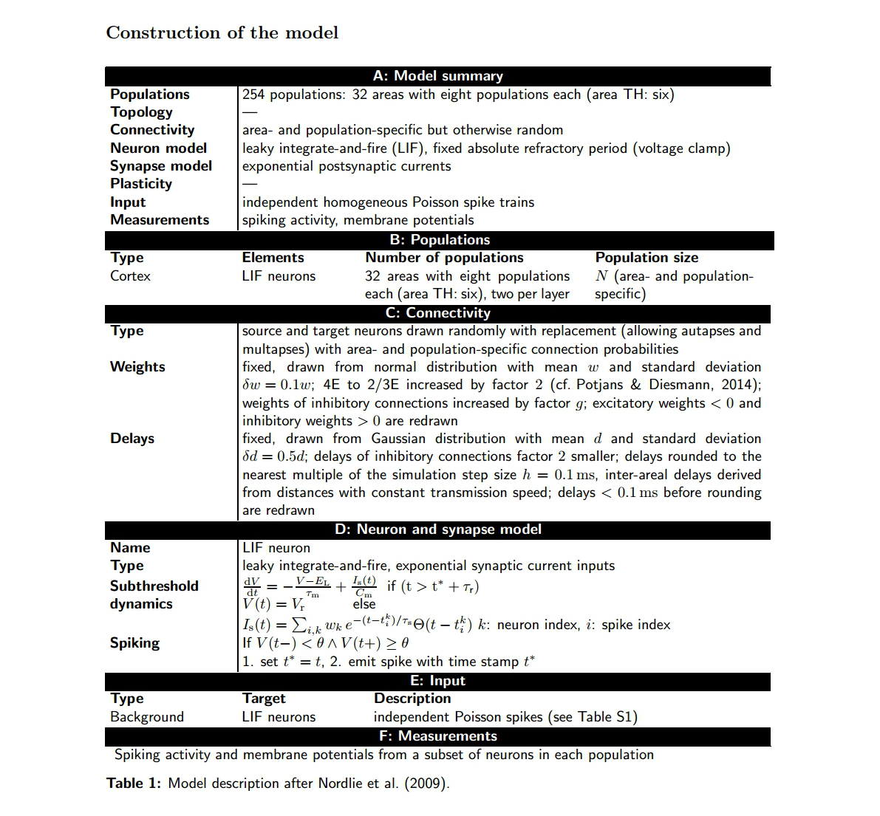

Table 1  
Description of the construction of the multi-area model extracted from Schmidt et al., 2015. The construction of the microcircuit for each area is based on Potjans and Diesmann, 2012.

*Figure 1: Description of each local microcircuit, of which we will consider several, representing different cortical areas.*

### References:

Bastos, A. M., Vezoli, J., Bosman, C. A., Schoffelen, J. M., Oostenveld, R., Dowdall, J. R., ... & Fries, P. (2015). Visual areas exert feedforward and feedback influences through distinct frequency channels. *Neuron*, *85*(2), 390-401.

Brunel, N. (2000). Dynamics of sparsely connected networks of excitatory and inhibitory spiking neurons. *Journal of computational neuroscience*, *8*(3), 183-208.

Felleman, D. J., & Van Essen, D. C. (1991). Distributed hierarchical processing in the primate cerebral cortex. *Cerebral cortex*, *1*(1), 1-47.

Gewaltig, M. O., & Diesmann, M. (2007). NEST (neural simulation tool). *Scholarpedia*, *2*(4), 1430.  
http://www.scholarpedia.org/article/NEST_%28NEural_Simulation_Tool%29

Jensen, O., Bonnefond, M., Marshall, T. R., & Tiesinga, P. (2015). Oscillatory mechanisms of feedforward and feedback visual processing. *Trends in Neurosciences*, *38*(4), 192-194.

Van Kerkoerle, T., Self, M. W., Dagnino, B., Gariel-Mathis, M. A., Poort, J., van der Togt, C., & Roelfsema, P. R. (2014). Alpha and gamma oscillations characterize feedback and feedforward processing in monkey visual cortex. *Proceedings of the National Academy of Sciences*, *111*(40), 14332-14341.

Markov, N. T., Vezoli, J., Chameau, P., Falchier, A., Quilodran, R., Huissoud, C., ... & Barone, P. (2014). Anatomy of hierarchy: feedforward and feedback pathways in macaque visual cortex. *Journal of Comparative Neurology,* 522(1), 225-259.

Potjans, T. C., & Diesmann, M. (2014). The cell-type specific cortical microcircuit: relating structure and activity in a full-scale spiking network model. *Cerebral Cortex*, *24*(3), 785-806.

Richardson, M. J., Brunel, N., & Hakim, V. (2003). From subthreshold to firing-rate resonance. *Journal of neurophysiology*, *89*(5), 2538-2554.

Saalmann, Y. B., Pinsk, M. A., Wang, L., Li, X., & Kastner, S. (2012). Pulvinar regulates information transmission between cortical areas based on attention demands. *Science (New York, N.Y.)*, *337*(6095), 753–756. http://doi.org/10.1126/science.1223082

Schmidt M, Bakker R, Diesmann M, van Albada SJ (2015) Construction of a multi-scale spiking model of macaque visual cortex. *arXiv*:1511.09364. Preprint available at: http://arxiv.org/abs/1511.09364

Self, M. W., Kooijmans, R. N., Supèr, H., Lamme, V. A., & Roelfsema, P. R. (2012). Different glutamate receptors convey feedforward and recurrent processing in macaque V1. *Proceedings of the National Academy of Sciences*, 109(27), 11031-11036.

Da Silva, F. L., Vos, J. E., Mooibroek, J., & Van Rotterdam, A. (1980). Relative contributions of intracortical and thalamo-cortical processes in the generation of alpha rhythms, revealed by partial coherence analysis. *Electroencephalography and Clinical Neurophysiology*, *50*(5), 449-456.

Silva, Laurie R., Yael Amitai, and Barry W. Connors (1991). Intrinsic oscillations of neocortex generated by layer 5 pyramidal neurons. *Science* 251(4992): 432.

Sun, W., & Dan, Y. (2009). Layer-specific network oscillation and spatiotemporal receptive field in the visual cortex. *Proceedings of the National Academy of Sciences*, 106(42), 17986-17991.**Signatures**

The signatories confirm the accuracy of all statements made on this form and agree to all principles and articles expresses as stated in the “MSc CNS Research Project Regulations”. **Note**: there may be more than one on-site supervisor stated, but at least one of them must have a PhD.

Student

Name Signature Date

*Mingers, Daniel*

On-site supervisor(s)

Title + Name Signature Date

*Dr. Sacha van Albada*

Educational supervisor *(if applicable)*

Title + Name Signature Date

*Prof. Dr. Paul Tiesinga*

Coordinator MSc CNS programme

Name Signature Date

*Dr. Arno Koning*

1. Note that the MSc CNS student is always first author of his/her thesis and obligatory submission to the CNS Student Journal. However, the order of the authors should be reevaluated if a subsequent submission of the thesis to an external journal is considered.